**Name: Shaunak Deshpande**

**Div.: TY-IC-C**

**Roll. No.: 39**

**GR no.: 11911180**

**Batch.: 2**

**Title:** Cascade Control.

In this exercise the AO block is used to change the process input. A change in the process input impacts the process outputs reflected in AI2 and AI1. The module used to simulate the process and the cascade control is shown below.

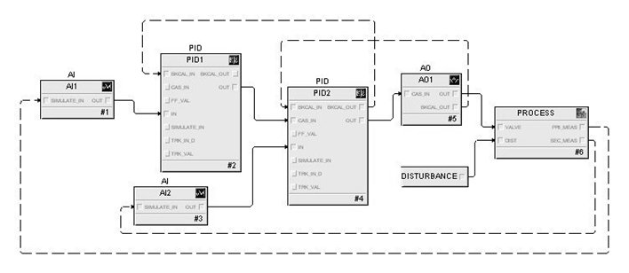

**Steps:**

Step 1. In the Cascade control workspace, set the mode of the slave loop (PID2) to manual. Make a step change in the OUT of PID2 and observe the response of the two process outputs. What difference is visible in the response of the two outputs?

Step 2. Place PID 2 in automatic mode and change the setpoint to 50. Observe the process response and also the automatic tracking that is done by the master loop.

Step 3. Place PID2 in cascade mode. With PID1 in manual mode, change the output of PID1 and observe the change in the setpoint of PID2.

Step 4. Place PID1 in automatic mode and observe the response when a change is made in the setpoint. With PID2 in cascade mode and PID1 in automatic mode, make a step change in the load disturbance. What impact was there on the slave loop? Did the master loop change as a result of the change in load disturbance?

Step 5. Enable FRSI_OPTS, Dynamic Reset Limit in PID1. Enable CONTROL_OPTS Use PV for BKCAL_OUT in PID2 and make a change in the PID1 setpoint. Is there any difference in the response?

Step 6. Enable BYPASS in PID2 and observe the difference in response when the setpoint of PID1 is changed.

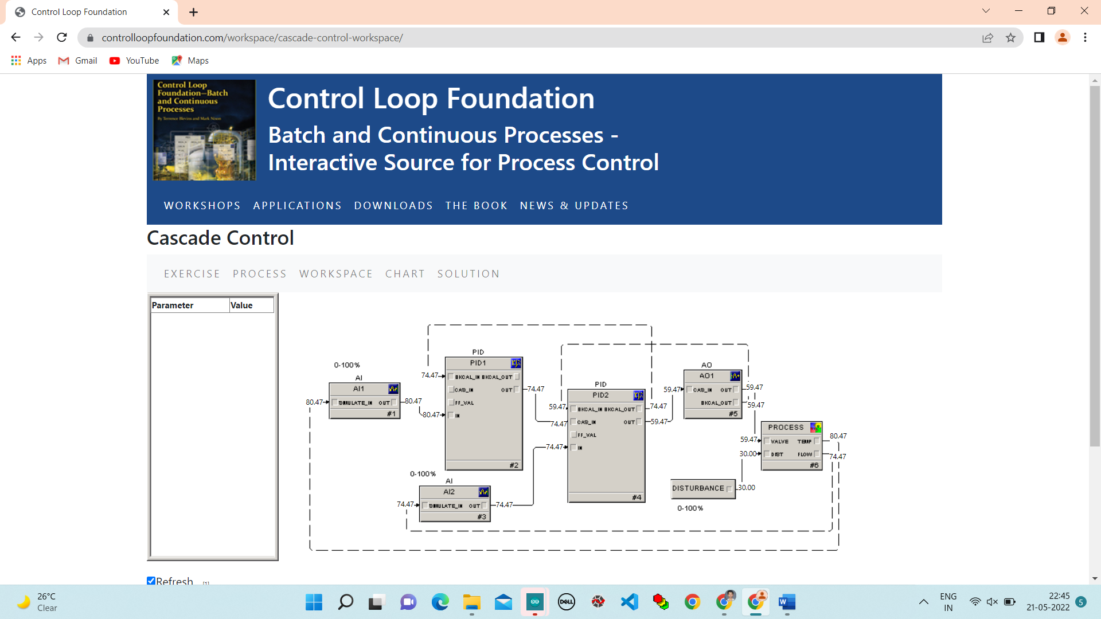

**Step 1.** In the Cascade control workspace, set the mode of the slave loop (PID2) to manual. Make a step change in the OUT of PID2 and observe the response of the two process outputs. What difference is visible in the response of the two outputs?

Change Mode of PID2 to MANUAL.

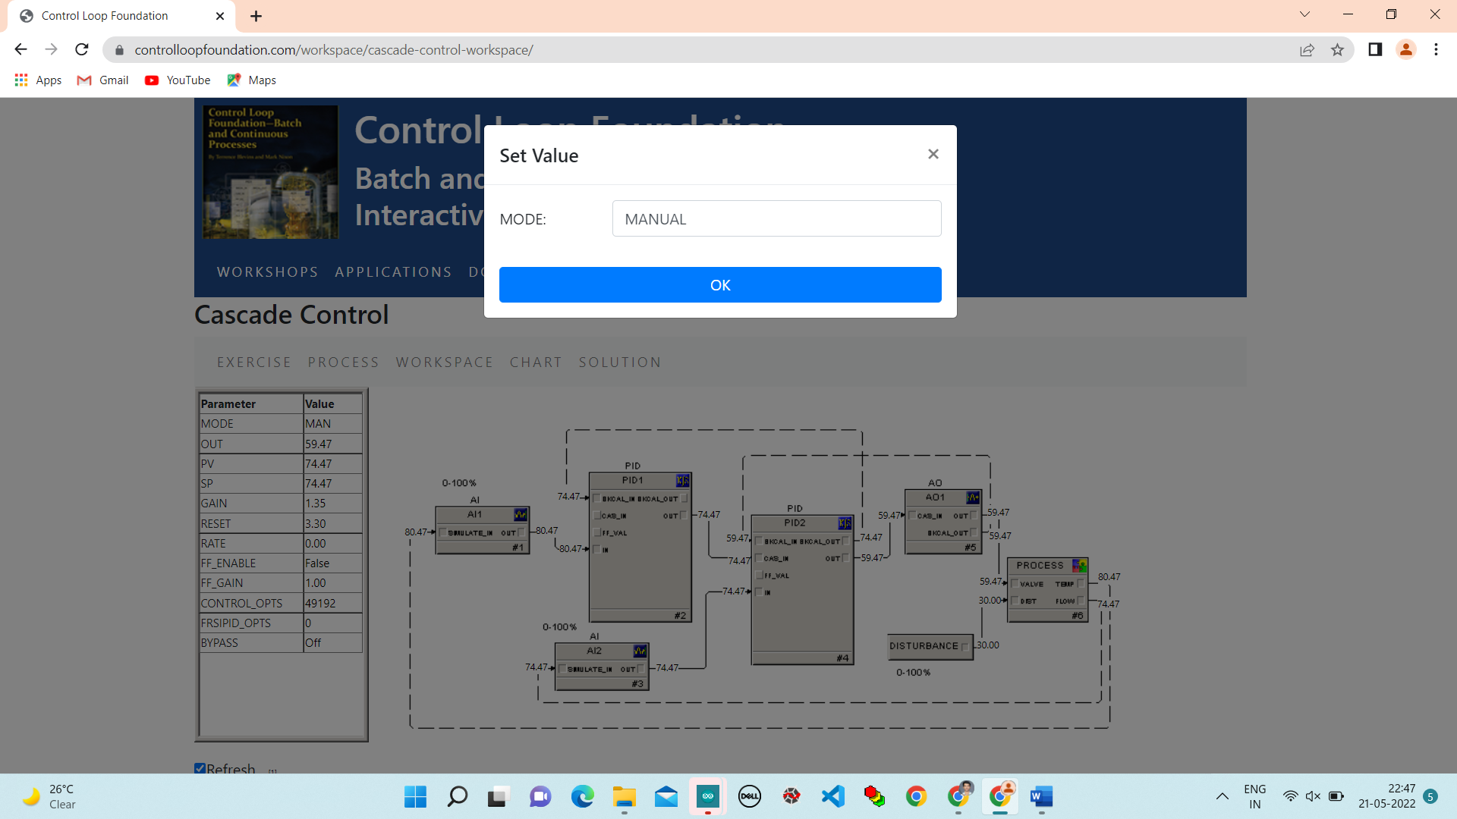

Change Output from 60 to 70.

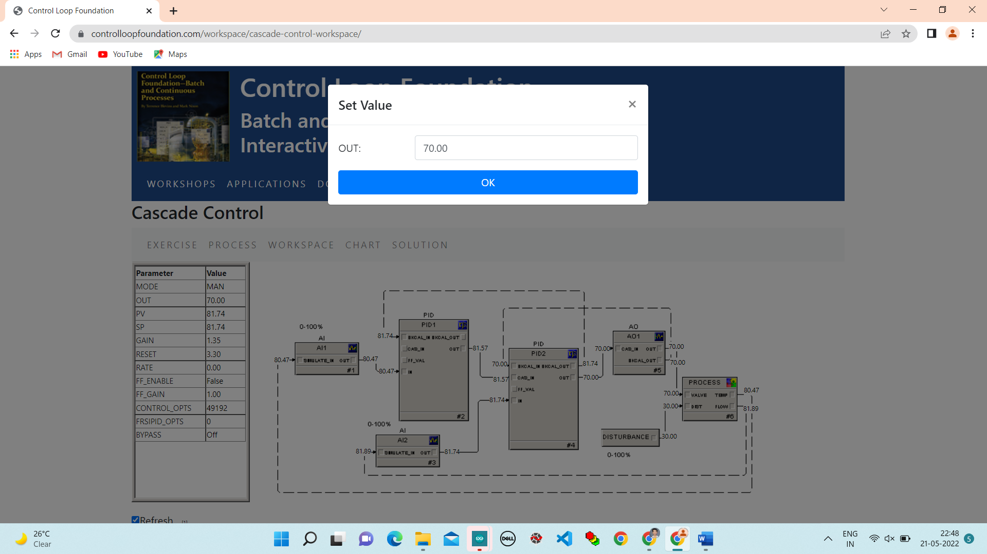

**Chart**:

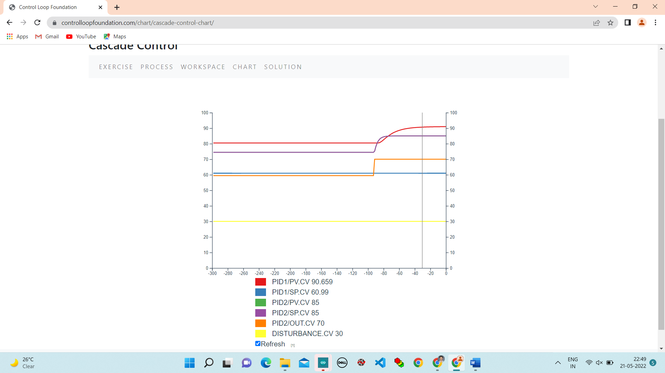

**Step 2.** Place PID 2 in automatic mode and change the setpoint to 50. Observe the process response and also the automatic tracking that is done by the master loop.

Change Mode of PID2 to Auto.

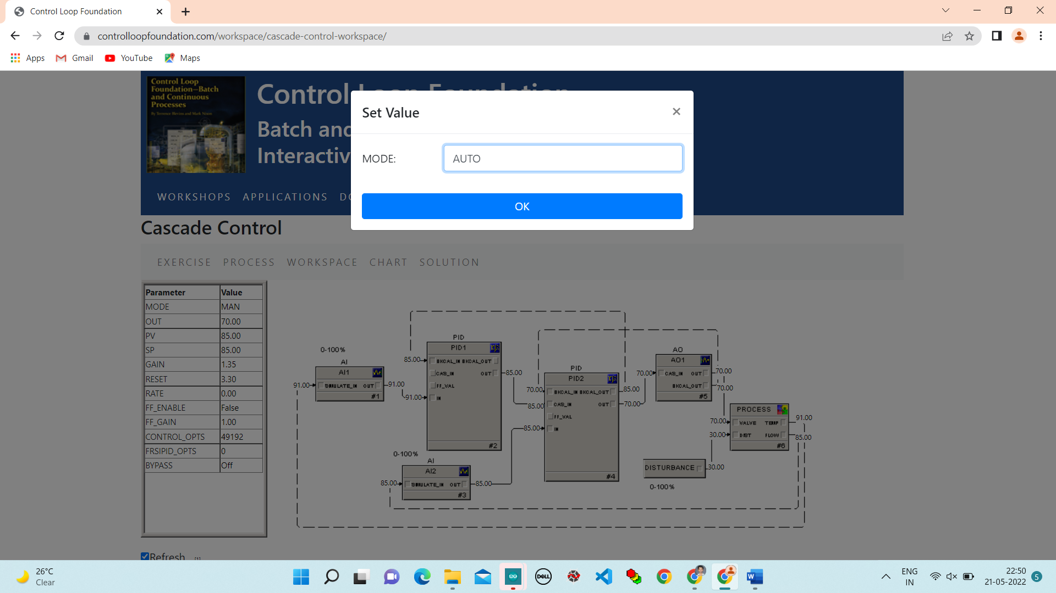

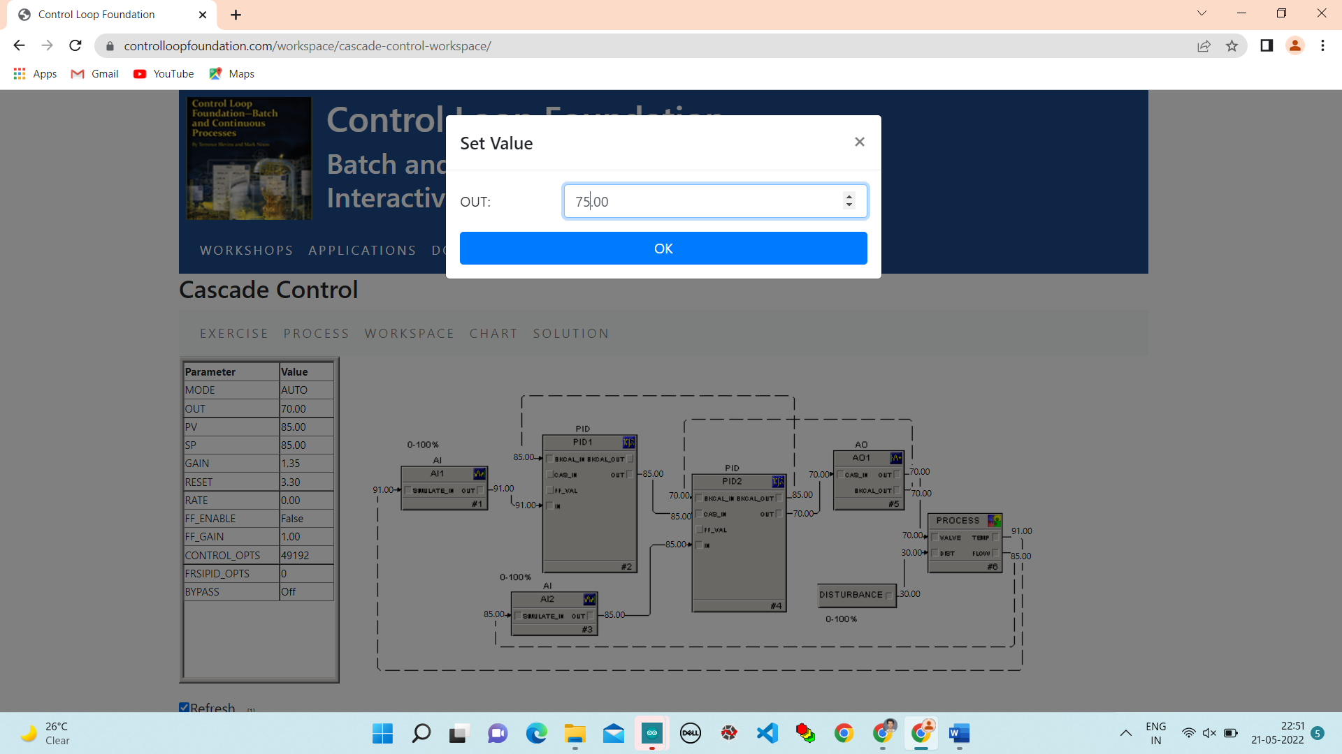

**Step 3.** Place PID2 in cascade mode. With PID1 in manual mode, change the output of PID1 and observe the change in the setpoint of PID2.

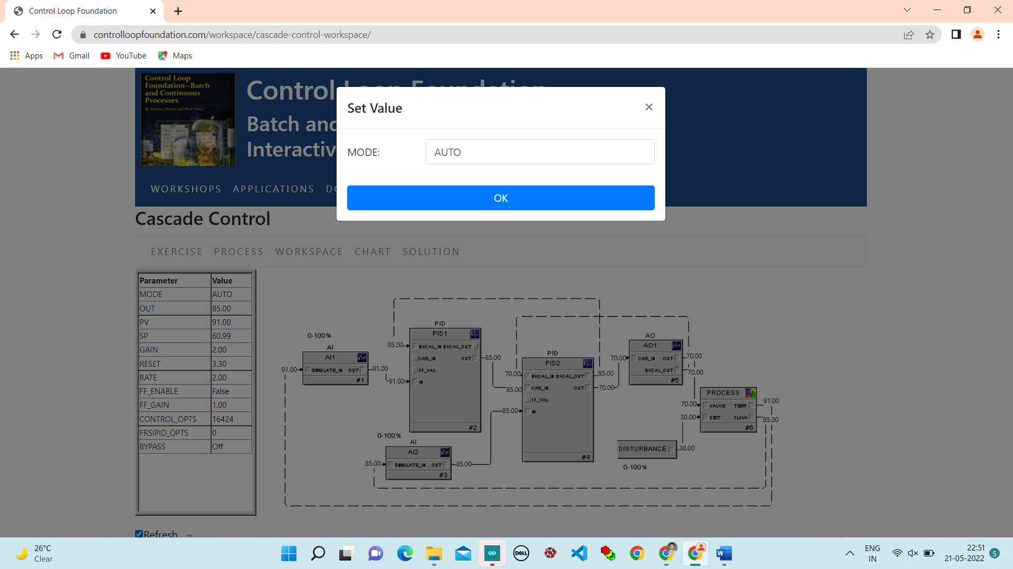

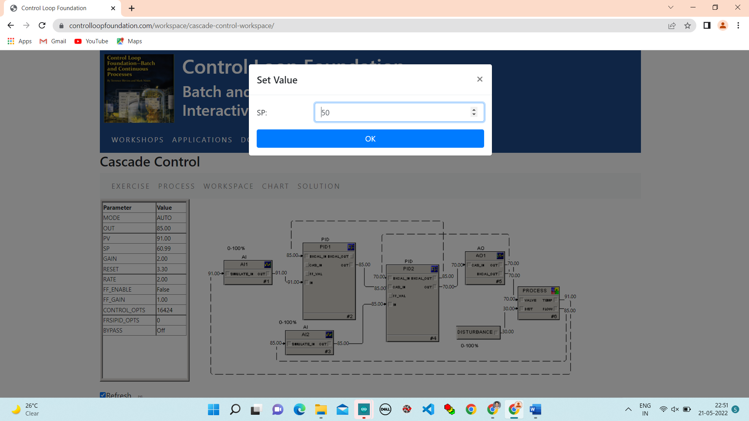

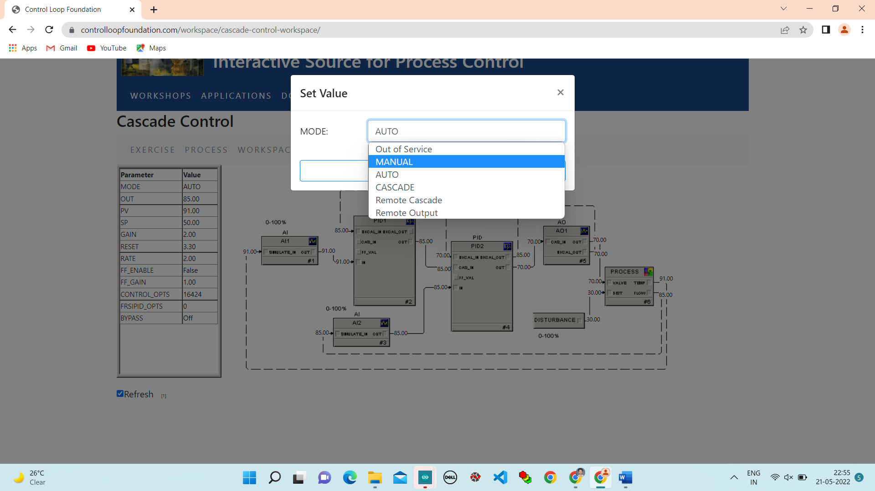

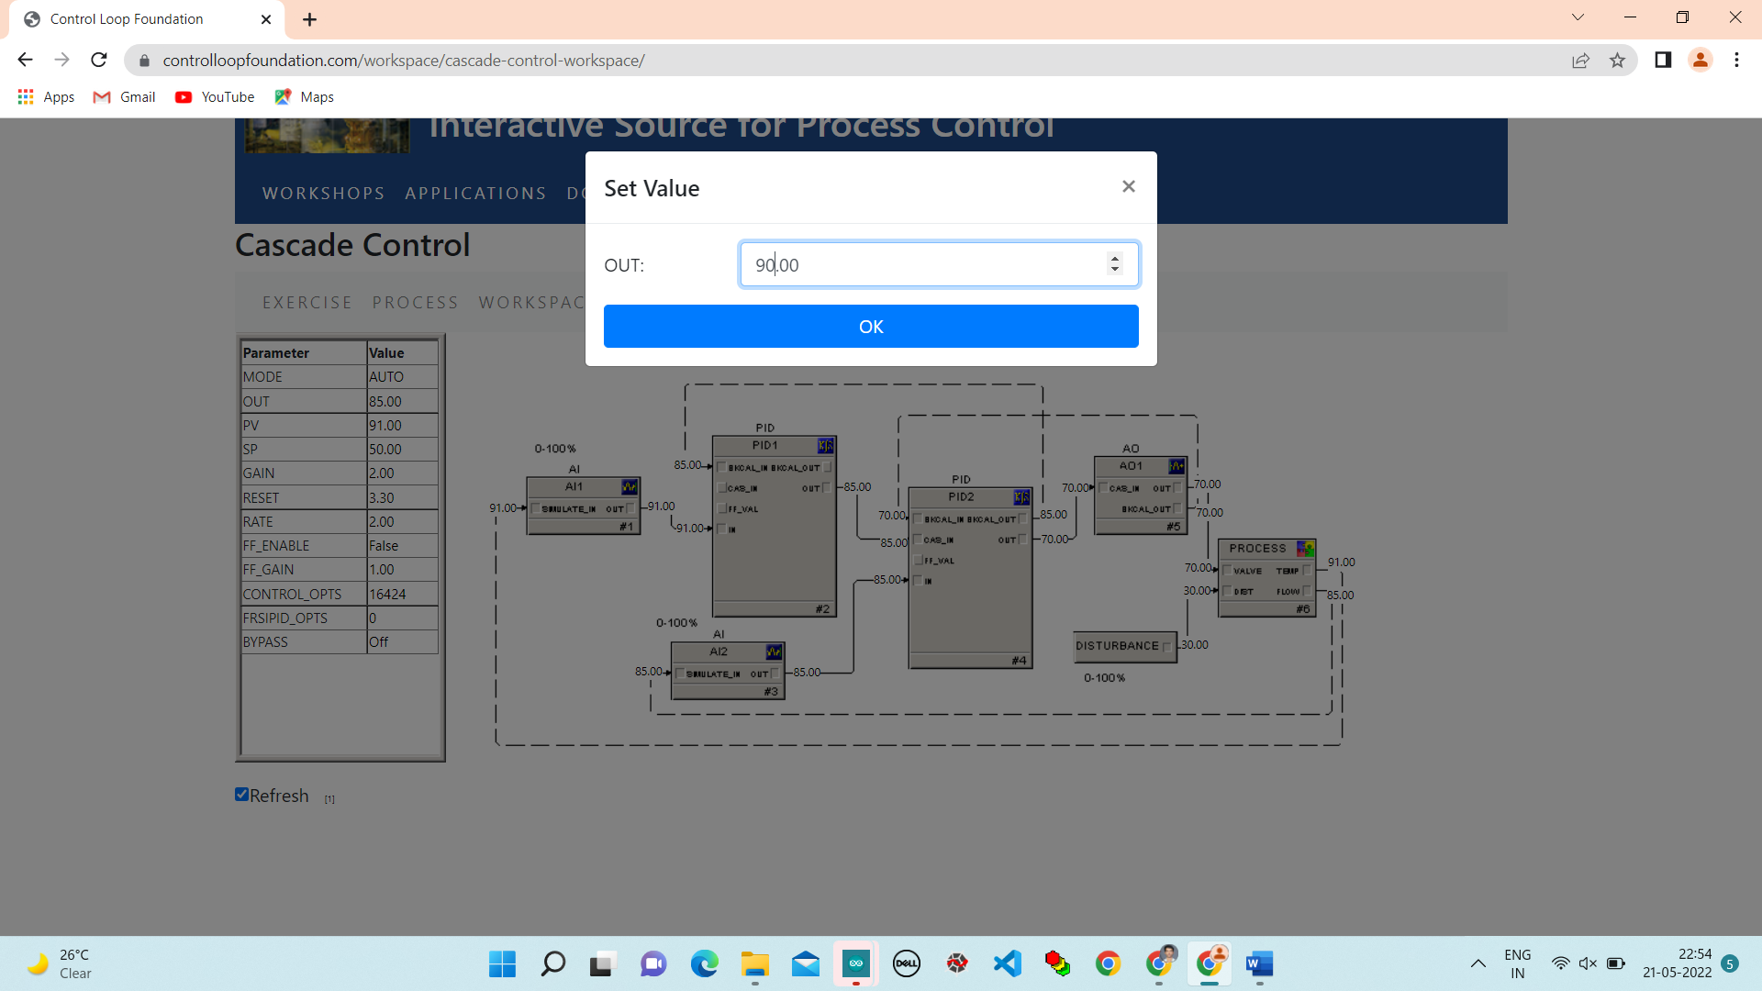

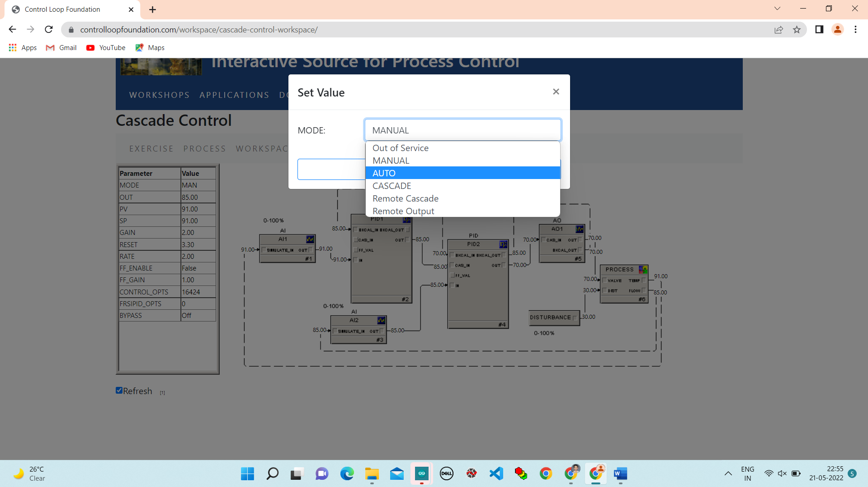

**Chart:**

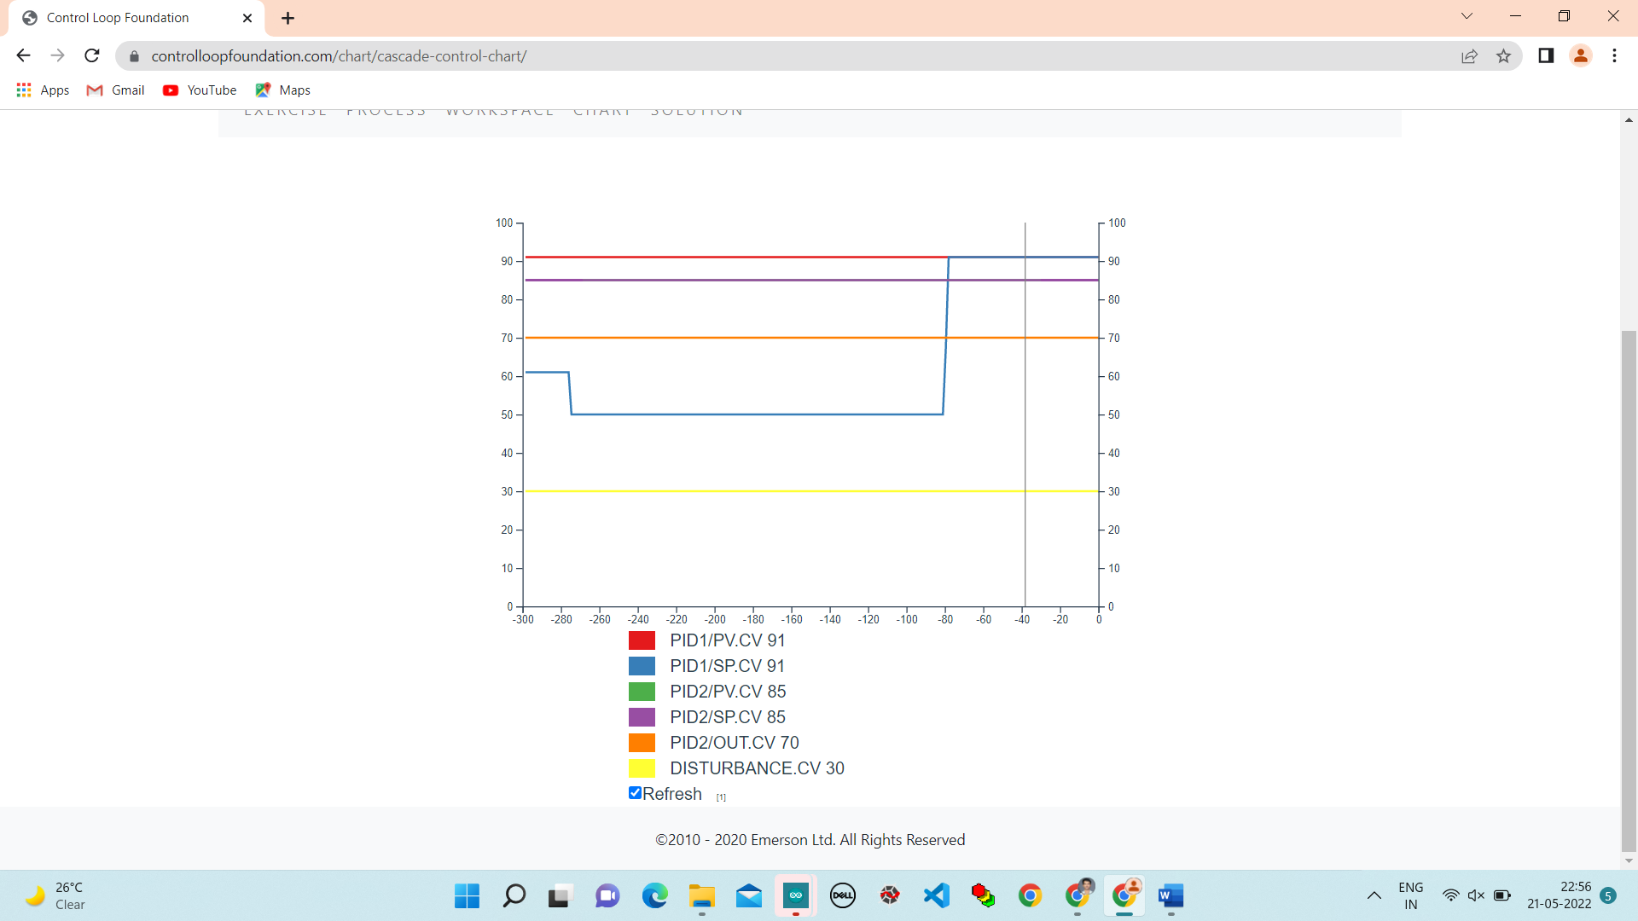

**Step 4.** Place PID1 in automatic mode and observe the response when a change is made in the setpoint. With PID2 in cascade mode and PID1 in automatic mode, make a step change in the load disturbance. What impact was there on the slave loop? Did the master loop change as a result of the change in load disturbance?

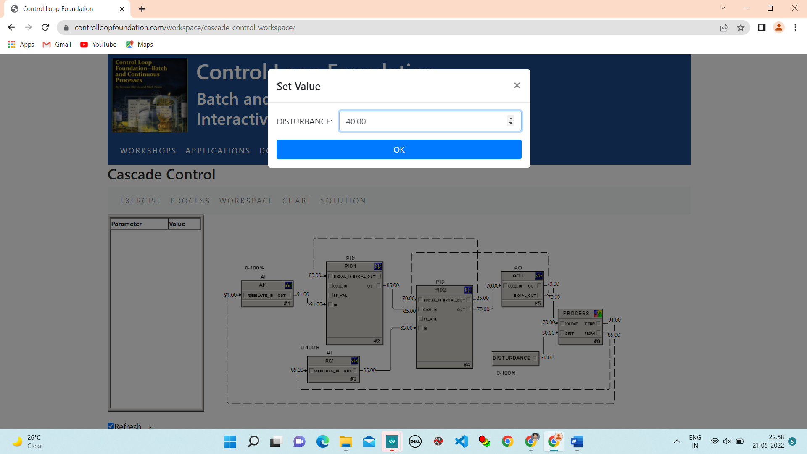

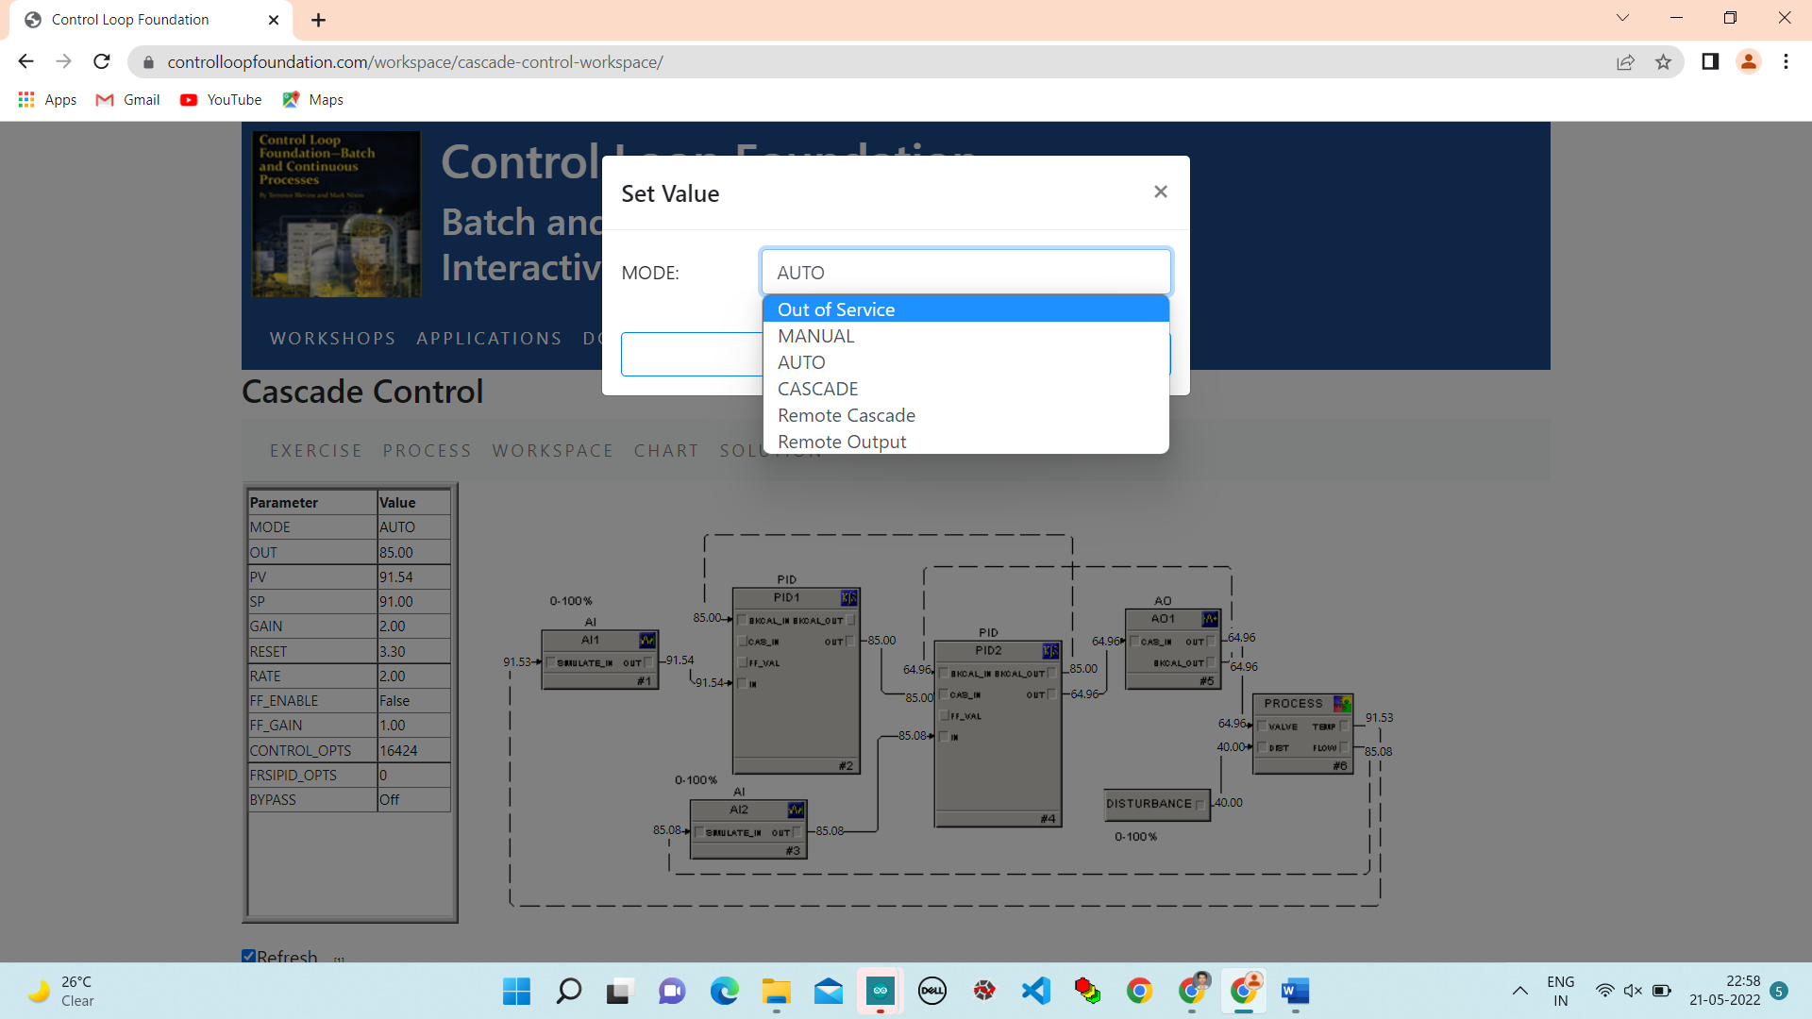

**Step 5.** Enable FRSI_OPTS, Dynamic Reset Limit in PID1. Enable CONTROL_OPTS Use PV for BKCAL_OUT in PID2 and make a change in the PID1 setpoint. Is there any difference in the response?

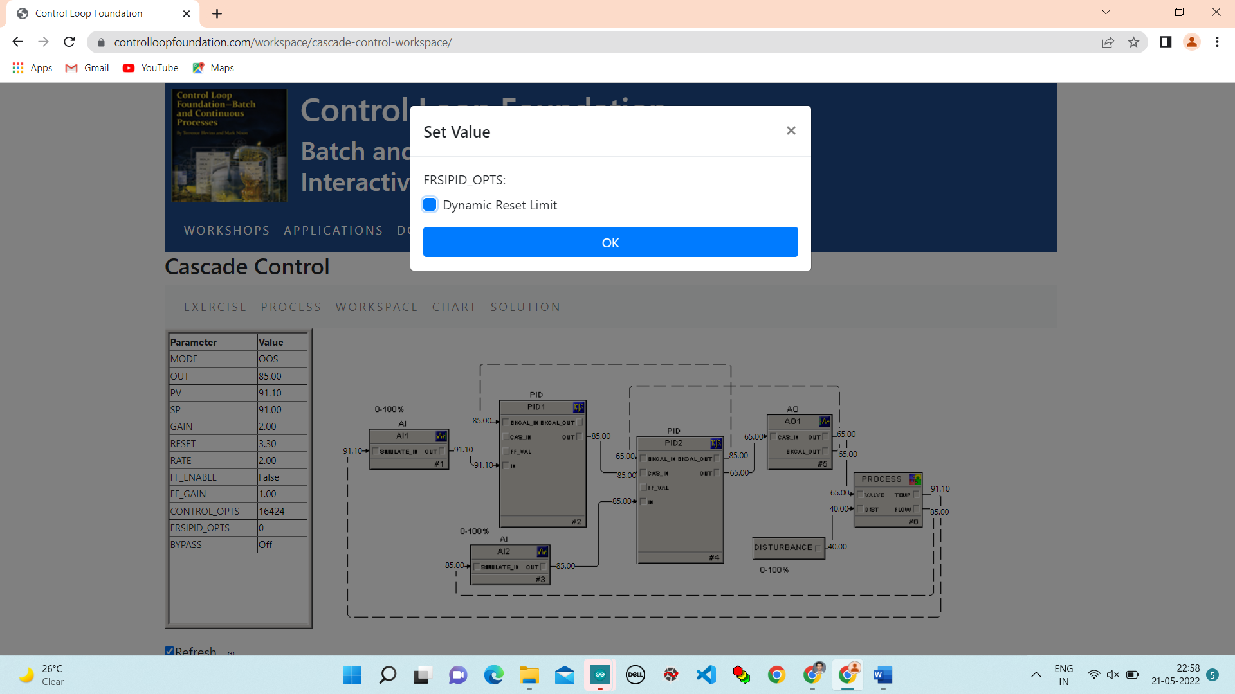

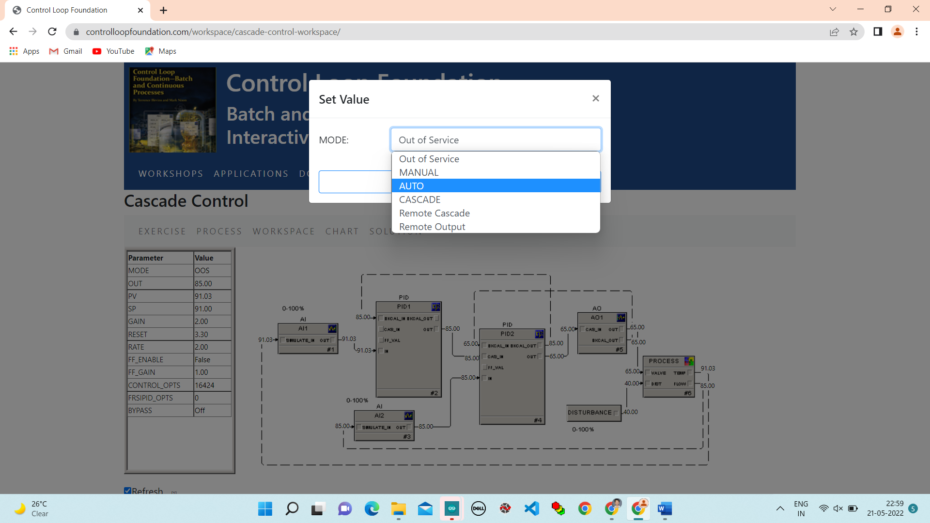

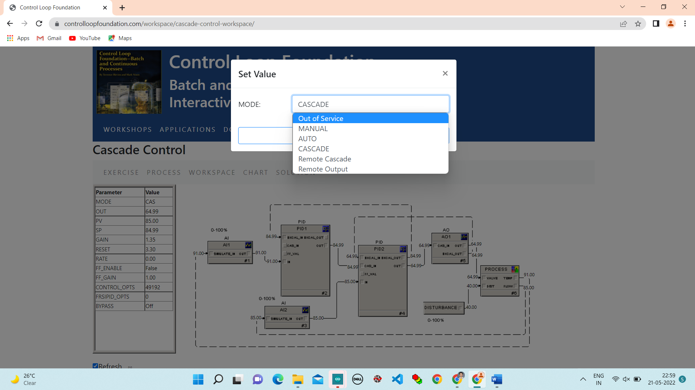

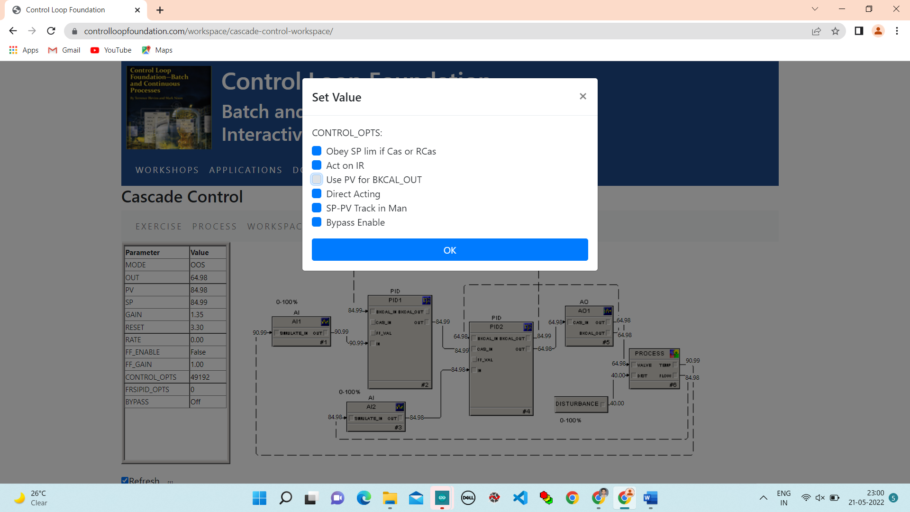

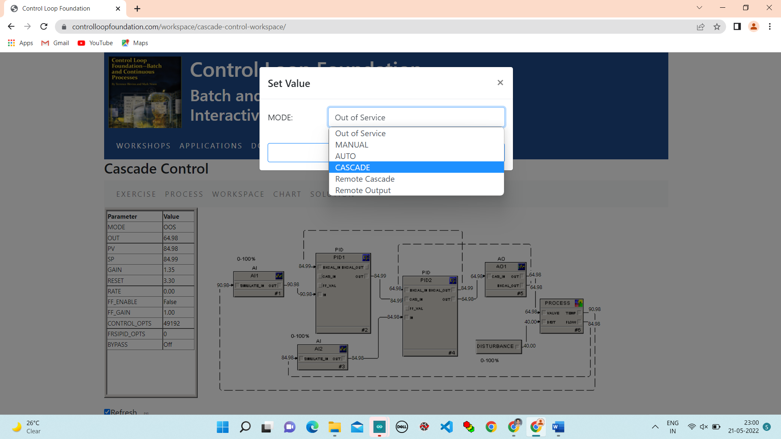

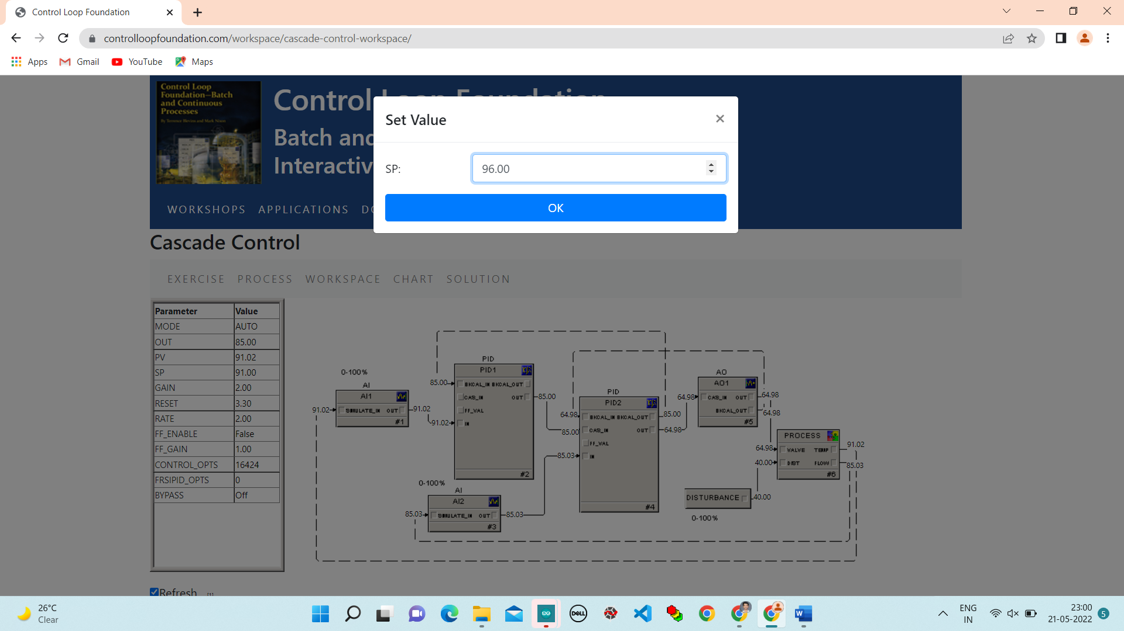

**Chart:**

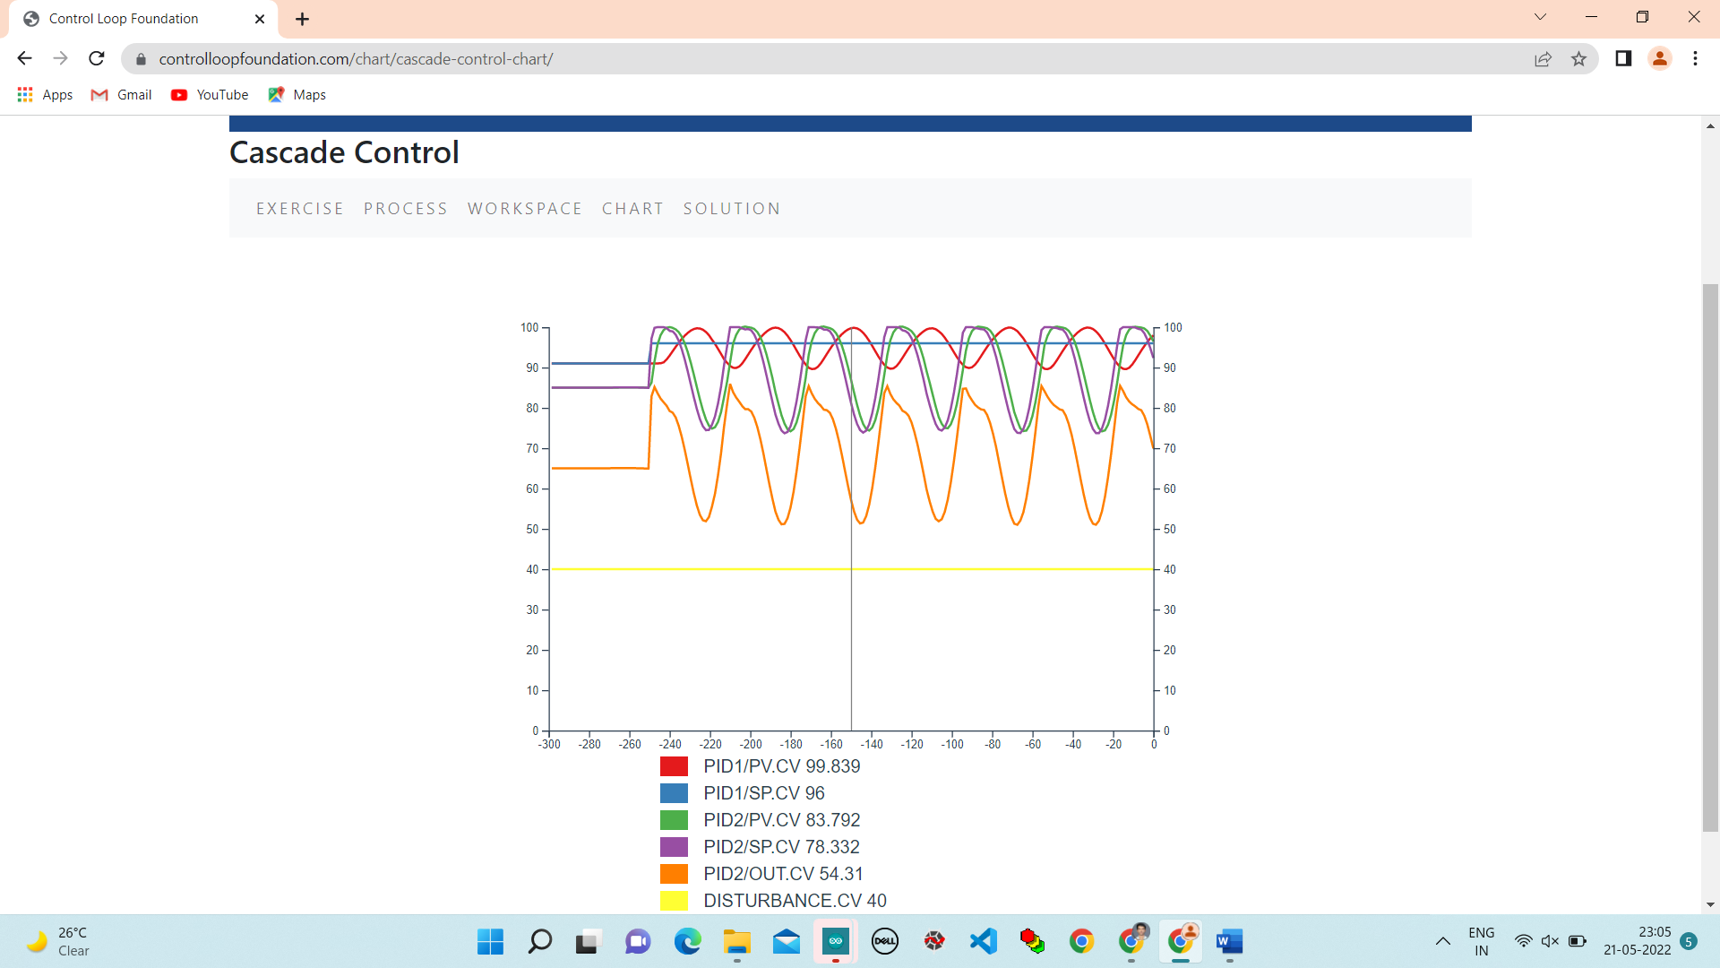

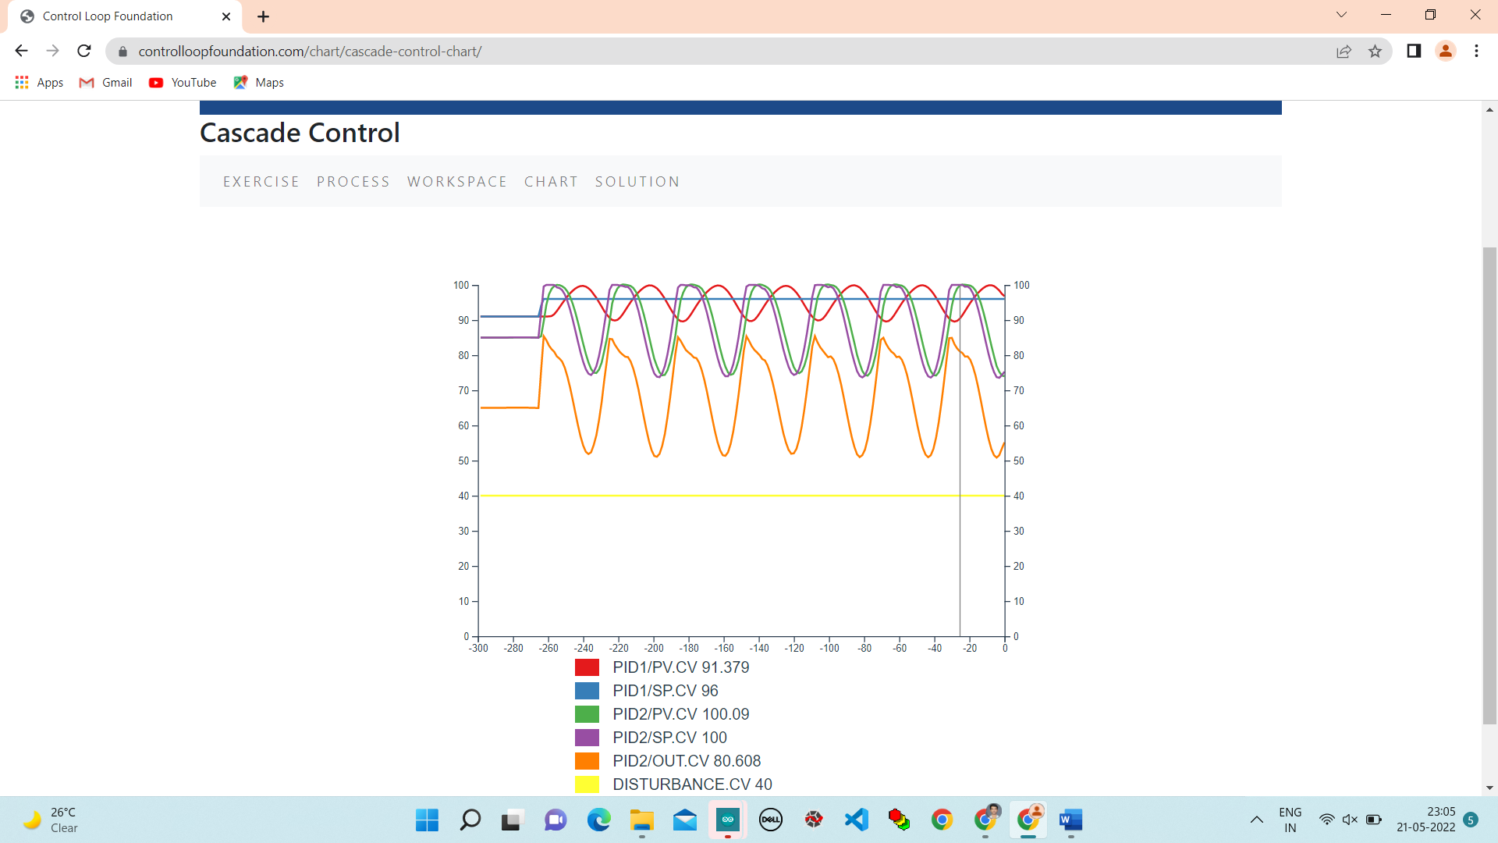

**Step 6.** Enable BYPASS in PID2 and observe the difference in response when the setpoint of PID1 is changed.

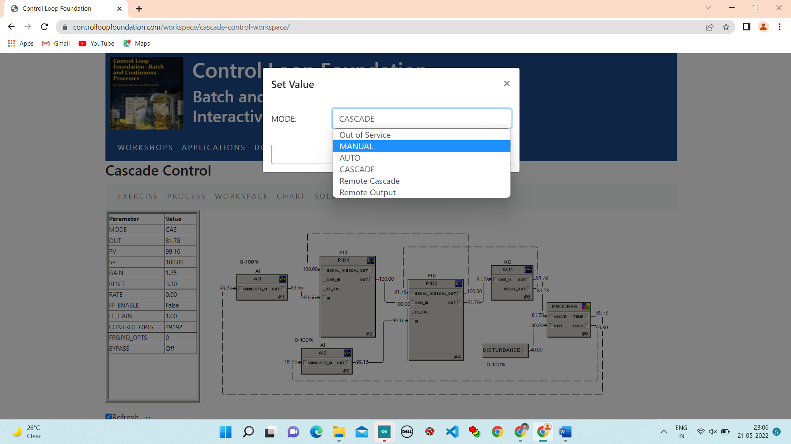

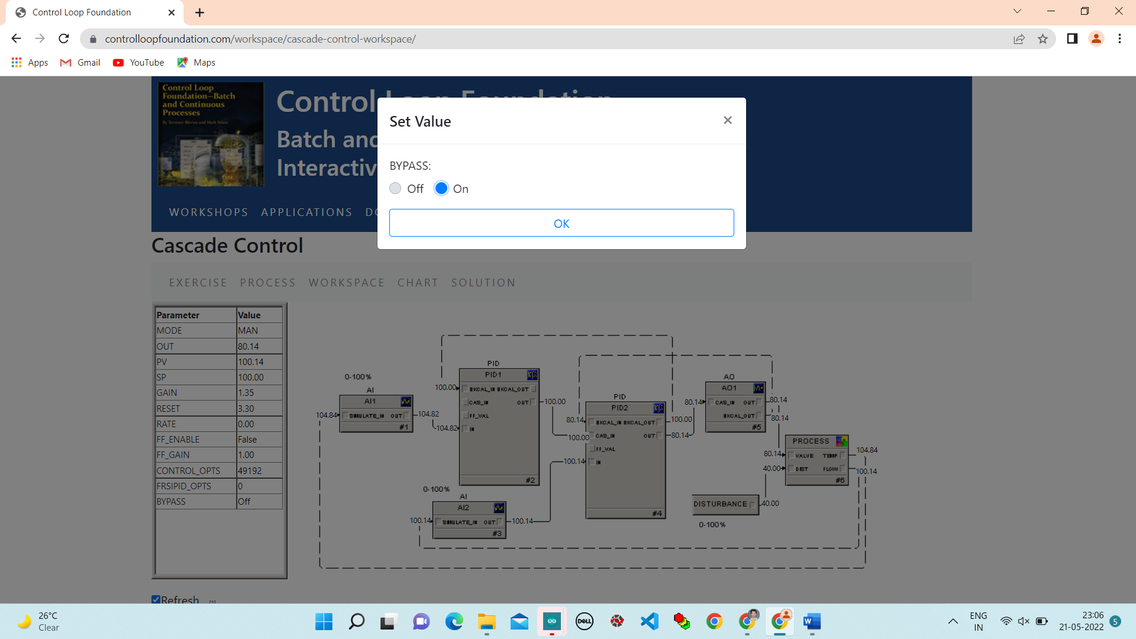

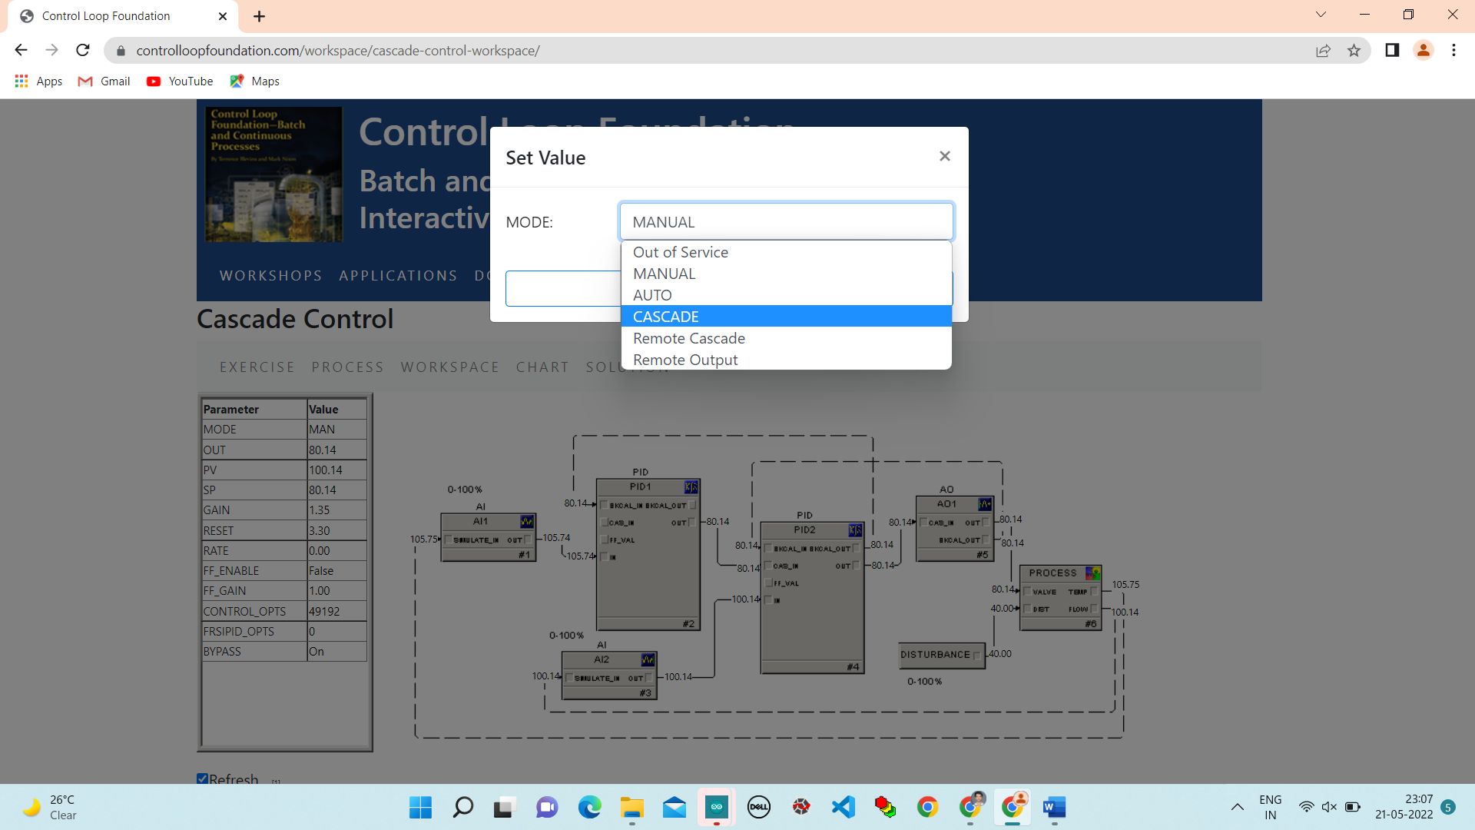

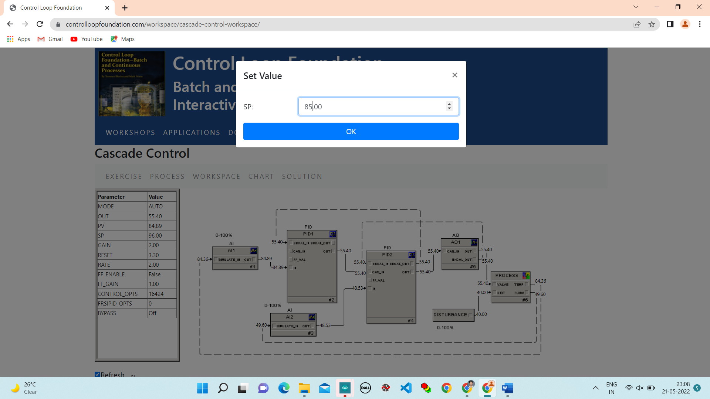

**Chart:**

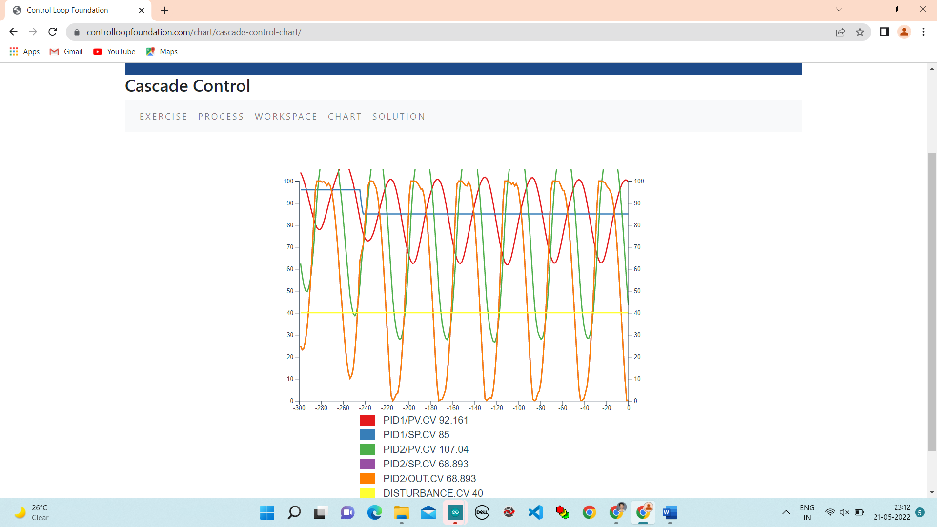

**Conclusion:**

In this lab we studied about cascade control and benefits of dynamic reset and PID Bypass are performed through the controlloop foundation workshop and observe the responces.